Nuclear Magnetic Resonance (NMR) spectroscopy

Proton nuclear magnetic resonance spectroscopy provides...
- information about the hydrogen atoms in molecules

The basic elements of an NMR spectrometer

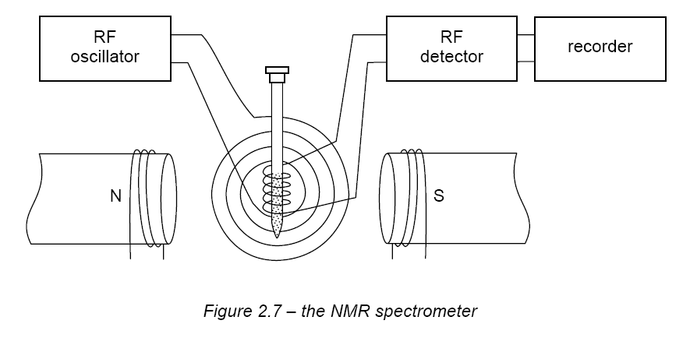

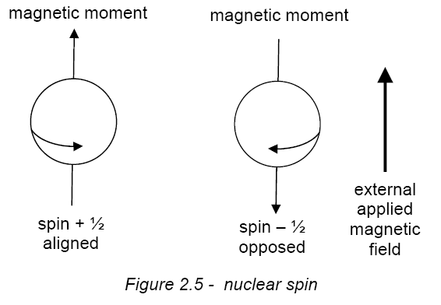

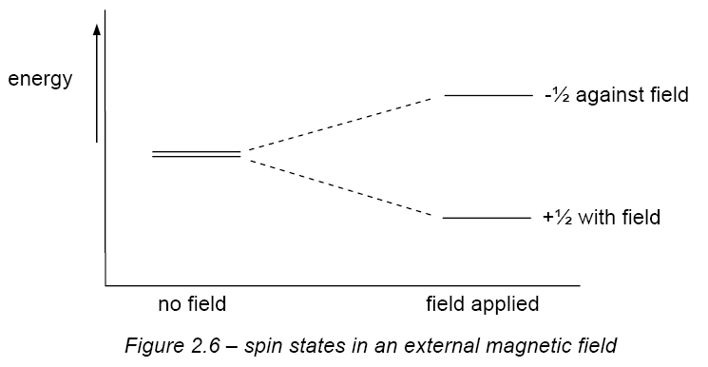
ΔΕ = hν

- Protons possess nuclear spin which generates a magnetic field.

- This magnetic field can align with or against to the applied external magnetic field.

- This split the protons into two different energy levels.

- The energy difference is in the radio frequency range.

- The energy difference depends on the chemical environment of the H.

Chemical shifts in NMR lies in the degree to which a magnetic nucleus is shielded from the applied magnetic field by electron surrounding the nucleus.

Shielding

- Protons are surrounded (shielded) only by σ-electrons which are spherically
symmetric in distribution around the nucleus.
- When a molecule is placed in an external field, the σ-electrons produce a
magnetic field which opposes the external field.

∴Shielding caused: - lower chemical shift
- lower δ
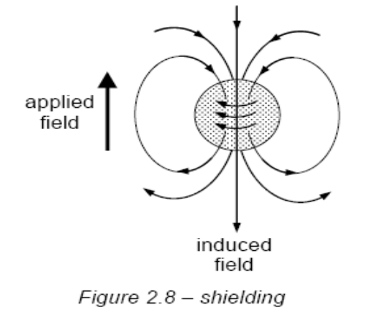

Deshielding

π-electrons also generate magnetic fields, but unlike the σ-electrons which always shield spinning nuclei, π-electrons may deshield spinning nuclei or shield spinning nuclei depending upon whether the lines of force (magnetic moment) generated by the π-electrons is parallel (deshield) or anti-parallel (shield).

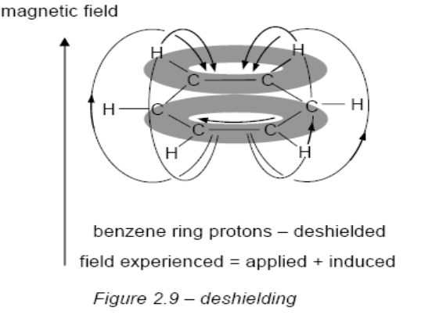
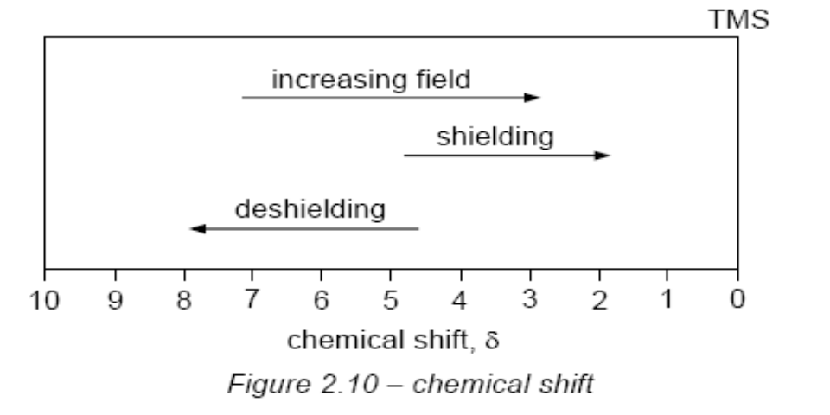

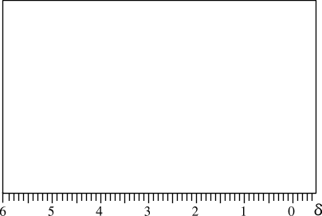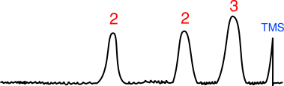
LOW RESOLUTION SPECTRUM OF 1-BROMOPROPANE

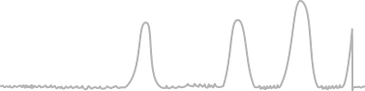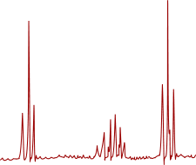
HIGH RESOLUTION SPECTRUM OF 1-BROMOPROPANE
The broad peaks are split into sharper signals

The –OH proton is a singlet

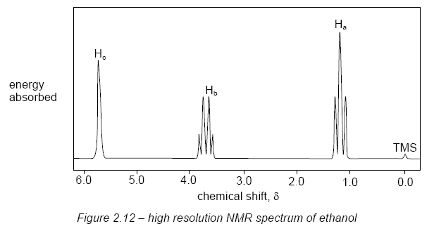

- You might have expected it to be split by the adjacent -CH₂- protons into a triplet & expected the -CH₂- protons to appear as a quintet – split by the three -CH₃ protons and also by the -OH proton.

- This splitting does not occur because protons on –OH groups undergo rapid exchange with each other, and with protons on other –OH groups such as those in water..

CH₃CH₂OH + H₂O ⇌ CH₃CH₂OH + HOH

- A useful application of this ready exchange of –OH protons is the disappearance of their absorption peak when an NMR sample is shaken with D₂O (D is deuterium, ²H).

CH₃CH₂OH + D₂O ⇌ CH₃CH₂OD + HOD

